- Hasil & Analisa Praktikum

Praktik Wajib 7 : Lingga
No | Gambar
 | Coding |  |  |  | Hasil/Output
1 | 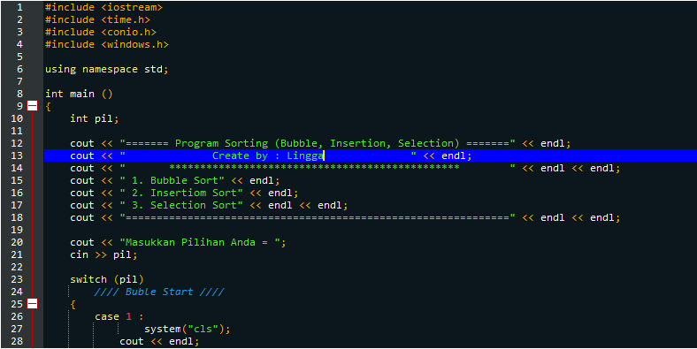  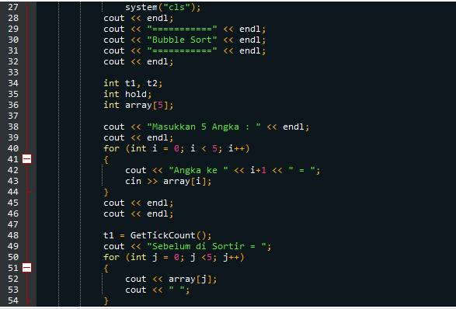  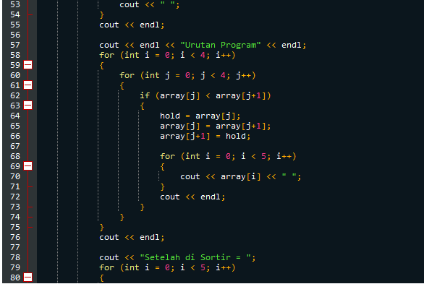  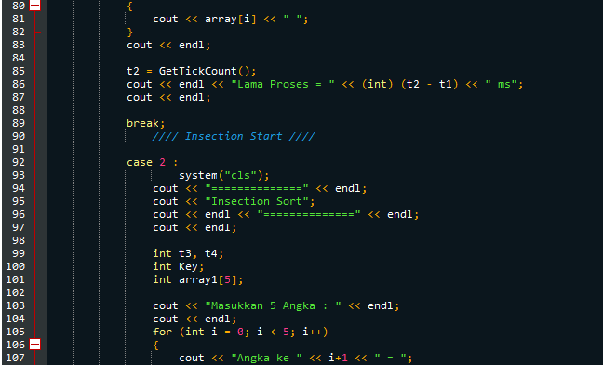  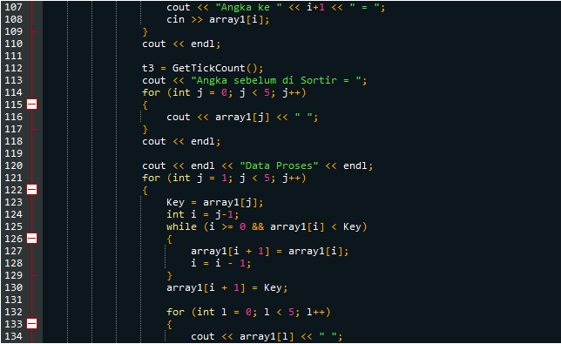  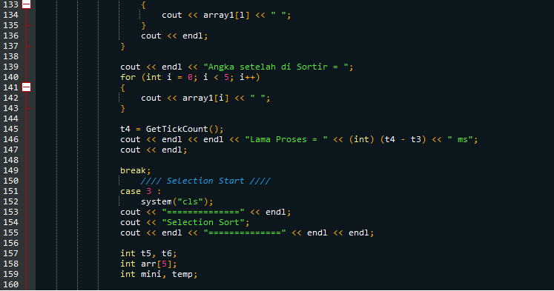  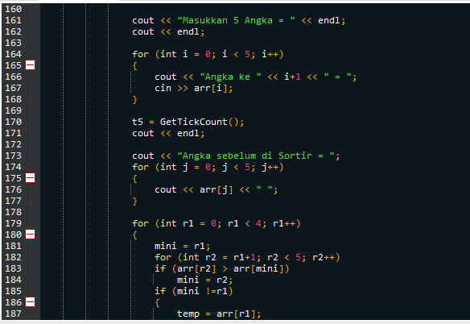  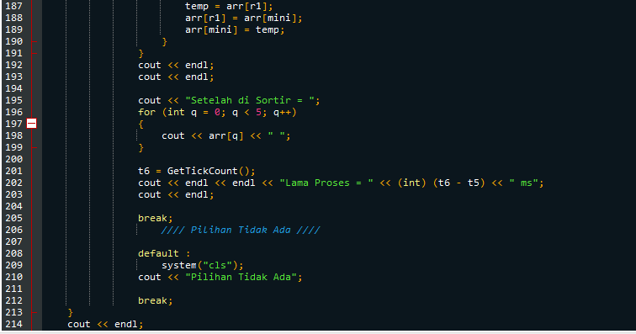  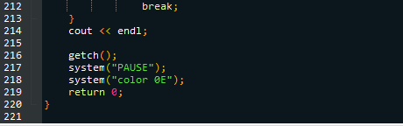 |  |  |  | 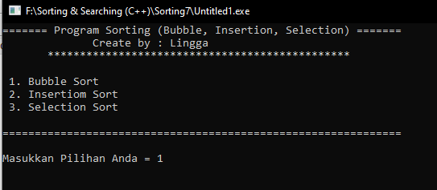  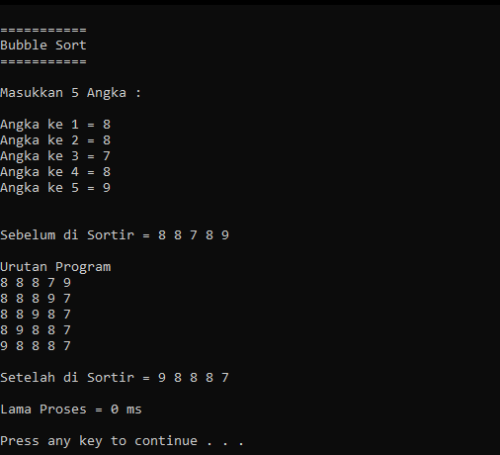
Analisa
------------------------------------------------------------------------------------------------------------------------------------------------------------------------------------------------------------------------------------------------------------------------------------------------------------------------------------------------------------------------------------------------------------------------------------------------------------------------------------------------------------------------------------------------------------------------------------------------------------------------------------------------------------------------------------------------------------------------------------------------------------------------------------------------------------------------------------------------------------------------------------------------------------------------------------------------------------------------------------------------------------------------------------------------------------------------------------------------------------------------------------------------------------------------------------------------------------------------------------------------------------------------------------------------------------------------------------------------------------------------------------------------------------------------------------------------------------------------------------------------------------------------------------------------------------------------------------------------------------------------------------------------------------------------------------------------------------------------------------------------------------------------------------------------------------------------------------------------------------------------------------------------------------------------------------------------------------------------------------------------------------------------------------------------------------------------------------------------------------------------------------------------------------------------------------------------------------------------------------------------------------------------------------------------------------------------------------------------------------------------------------------------------------------------------------------------------------------------------------------------------------------------------------------------------------------------------------------------------------------------------------------------------------------------------------------------------------------------------------------------------------------------------------------------------------------------------------------------------------------------------------------------------------------------------------------------------------------------------------------------------------------------------------------------------------------------------------------------------------------------------------------------------------------------------------------------------------------------------------------------------------------------------------------------------------------------------------------------------------------------------------------------------------------------------------------------------------------------------------------------------------------------------------------------------------------------------------------------------------------------------------------------------------------------------------------------------------------------------------------------------------
Praktik Bebas 2 : Lingga
No | Gambar
 | Coding |  |  |  | Hasil/Output
2 | 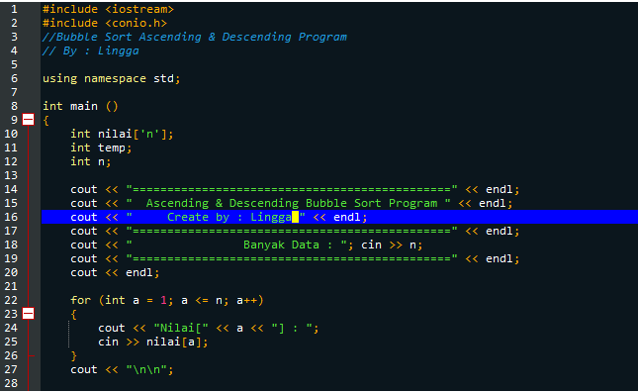  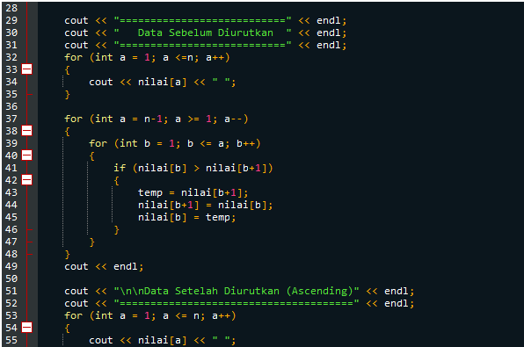  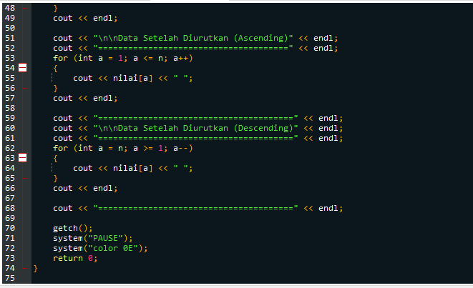 |  |  |  | 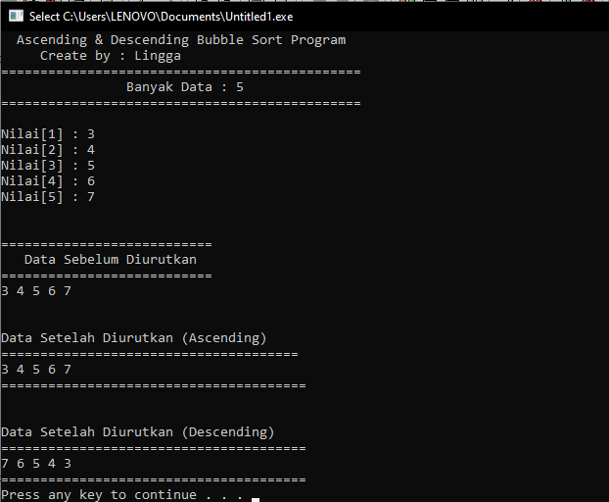
Analisa
------------------------------------------------------------------------------------------------------------------------------------------------------------------------------------------------------------------------------------------------------------------------------------------------------------------------------------------------------------------------------------------------------------------------------------------------------------------------------------------------------------------------------------------------------------------------------------------------------------------------------------------------------------------------------------------------------------------------------------------------------------------------------------------------------------------------------------------------------------------------------------------------------------------------------------------------------------------------------------------------------------------------------------------------------------------------------------------------------------------------------------------------------------------------------------------------------------------------------------------------------------------------------------------------------------------------------------------------------------------------------------------------------------------------------------------------------------------------------------------------------------------------------------------------------------------------------------------------------------------------------------------------------------------------------------------------------------------------------------------------------------------------------------------------------------------------------------------------------------------------------------------------------------------------------------------------------------------------------------------------------------------------------------------------------------------------------------------------------------------------------------------------
------------------------------------------------------------------------------------------------------------------------------------------------------------------------------------------------------------------------------------------------------------------------------------------------------------------------------------------------------------------------------------------------------------------------------------------------------------------------------------------------------------------------------------------------------------------------------------------------------------------------------------------------------------------------------------------------------------------------------------------------------------------------------------------------------------------------------------------------------------------------------------------------------------------------------------------------------------------------------------------------------------------------------------------------------------------------------------------------------------------------------------------------------------------------------------------------------------------------------------------------------------------------------------------------------------------------------------------------------------------------------------------------------------------------------------------------------------------------------------------------------------------------------------------------------------------------------------------------------------
Praktik Bebas 4 : Lingga
No | Gambar
 | Coding |  | Hasil/Output
3 | 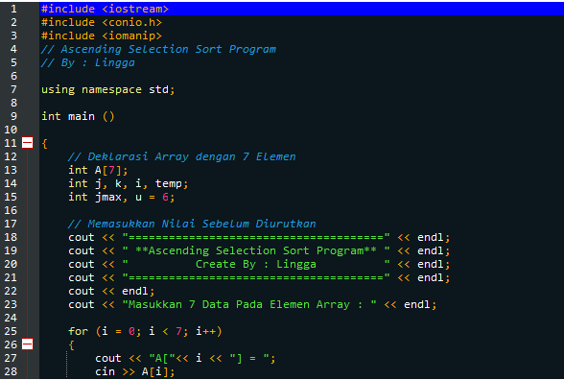  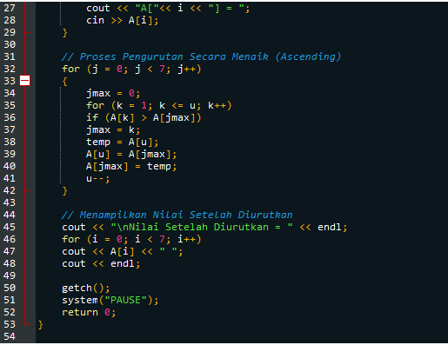 |  | 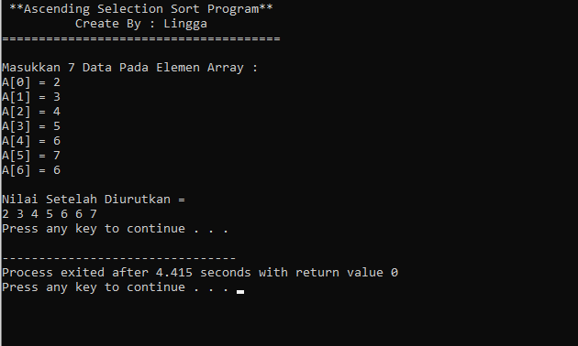
Analisa
--------------------------------------------------------------------------------------------------------------------------------------------------------------------------------------------------------------------------------------------------------------------------------------------------------------------------------------------------------------------------------------------------------------------------------------------------------------------------------------------------------------------------------------------------------------------------------------------------------------------------------------------------------------------------------------------------------------------------------------------------------------------------------------------------------------------------------------------------------------------------------------------------------------------------------------------------------------------------------------------------------------------------------------------------------------------------------------------------------------------------------------------------------------------------------------------------------------------------------------------------------------------------------------------------------------------------------------------------------------------------------------------------------------------------------------------------------------------------------------------------------------------------------------------------------------------------------------------------------------------------------------------------------------------------------------------------

Praktik Wajib 4 : Lingga
No | Gambar
 | Coding |  | Hasil/Output
4 | 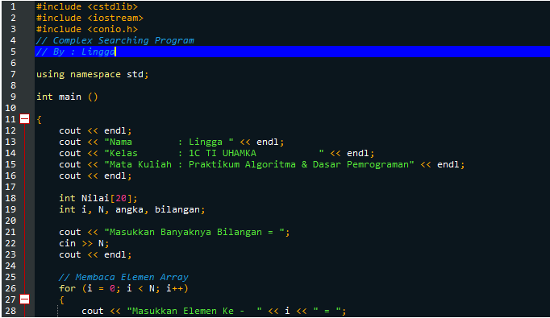  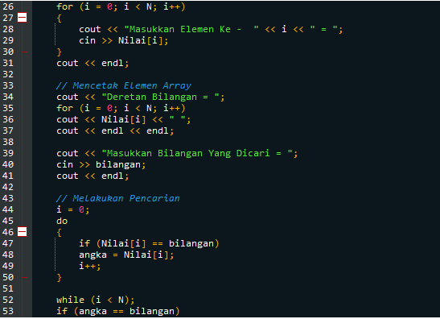  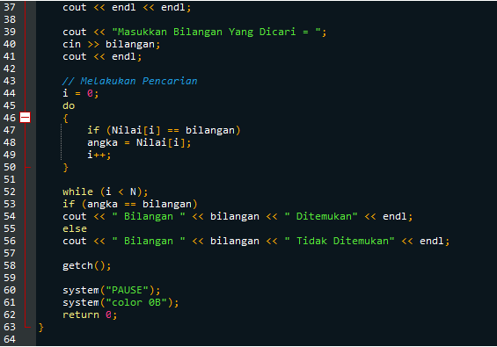 |  | 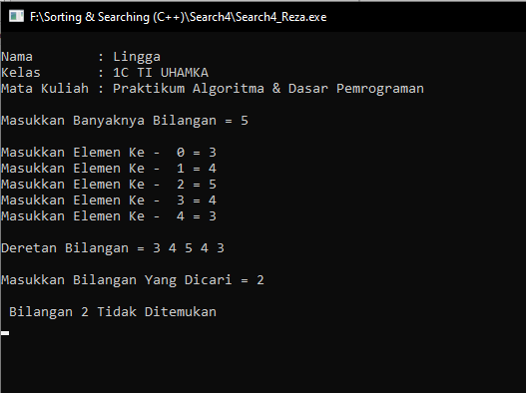
Analisa
--------------------------------------------------------------------------------------
--------------------------------------------------------------------------------------
--------------------------------------------------------------------------------------
--------------------------------------------------------------------------------------
--------------------------------------------------------------------------------------
--------------------------------------------------------------------------------------
--------------------------------------------------------------------------------------
--------------------------------------------------------------------------------------
--------------------------------------------------------------------------------------
--------------------------------------------------------------------------------------
--------------------------------------------------------------------------------------
--------------------------------------------------------------------------------------
--------------------------------------------------------------------------------------
--------------------------------------------------------------------------------------
Praktik Wajib 8 : Lingga
No |  | Gambar
 |  | Coding |  | Hasil/Output
5 |  | 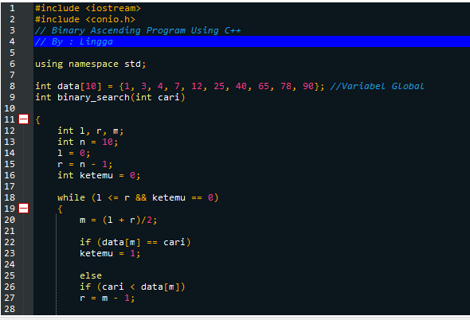  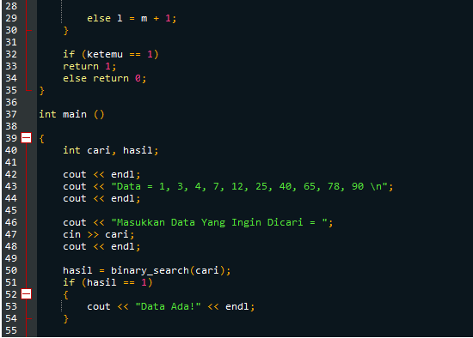  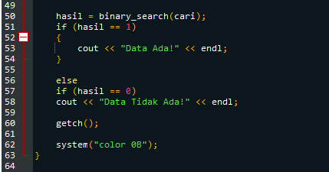 |  | 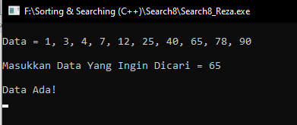
Analisa
------------------------------------------------------------------------------------------------------------------------------------------------------------------------------------------------------------------------------------------------------------------------------------------------------------------------------------------------------------------------------------------------------------------------------------------------------------------------------------------------------------------------------------------------------------------------------------------------------------------------------------------------------------------------------------------------------------------------------------------------------------------------------------------------------------------------------------------------------------------------------------------------------------------------------------------------------------------------------------------------------------------------------------------------------------------------------------------------------------------------------------------------------------------------------------------------------------------------------------------------------------------------------------------------------------------------------------------

Praktik Bebas 2 : Diana Fitri Lessy
No | Gambar
 | Coding | Hasil/Output
6 | 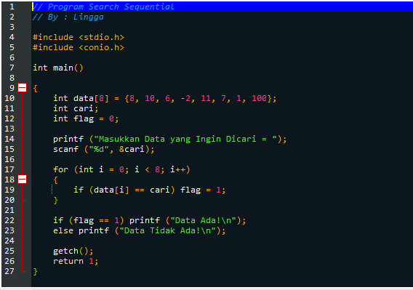 | 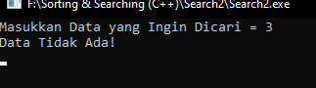
Analisa
--------------------------------------------------------------------------------------------------------------------------------------------------------------------------------------------------------------------------------------------------------------------------------------------------------------------------------------------------------------------------------------------------------------------------------------------------------------------------------------------------------------------------------------------------------------------------------------------------------------------------------------------------------------------------------------------------------------------------------------------------------------------------------------------------------------------------------------------------------------------------------------------------------------------------------------------------------------------------------------------------------------------------------------------------------------------------------------------------------------------------------------------------------------------------------------------------------------------------------------------------------------------------------------------------------------------------------------------------------------------------------------------------------------------------------------------------------------------------------------------------------------------------------------------------------------------------------------------------------------------------------------------------------------------------------------------------------------------------------------------------------------------------------------------------------------------------------------------------------------------------------------------------------------------------------------------------------------------

